FOS
Troubleshooting “Database Initializing” screen for an extended period of time
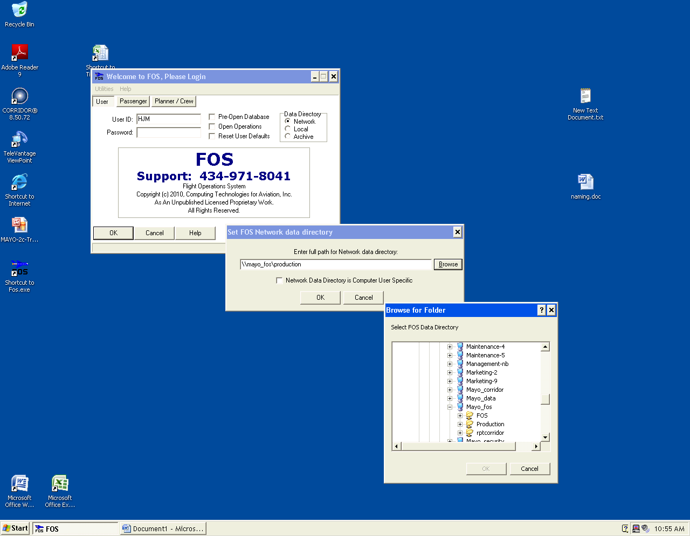
1
1. Select “Utilities”, “File Locations”, “Network Data Directory”
2. Select “Browse”
3. Expand “Mayo_FOS”
3
2
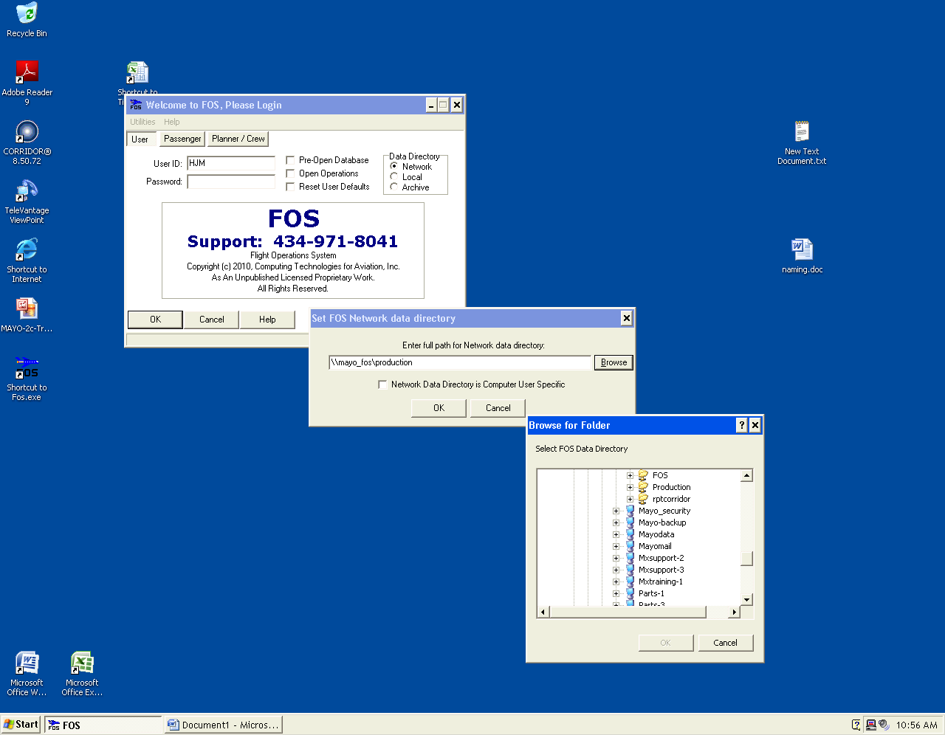
5
4
4. Select “Production”, click “OK”
5. In the Data Directory box, select “Network”

If you cannot log in after taking these steps, please contact the Administrator

